Start working on Bash-Scripting assignment-02.
1️. Check if a directory exists or not
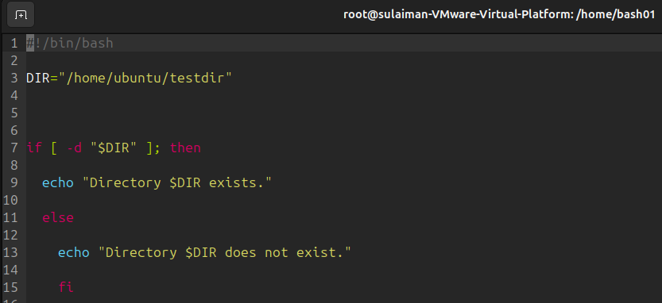
- #!/bin/bash = This is called the shebang. It tells your computer to use the Bash program to run the commands in the script.

- DIR="/home/ubuntu/testdir" = DIR is the name of the bookmark (a variable).
Example :- The variable DIR is in RAM (temporary memory). Or DIR is a temporary storage spot for the script to use, but it only stores the address of the real, permanent storage (the folder).

- 1 if [ -d "$DIR" ]; then = if (This starts the conditional statement.) ("START CHECK:")
2 [ ... ] = (These brackets hold the test condition. ) ("IS IT TRUE THAT...")
3 -d = This is the specific test command. ( "...THIS IS A FOLDER (Directory)?")
4 "$DIR" = (This is the variable holding the folder's address.) ( "...THE FOLDER AT THE ADDRESS WE SAVED (e.g., /home/ubuntu/testdir)?")
5 ; then= (This closes the question and says what to do next if the answer is Yes. ) ( "IF YES, DO THE NEXT THING.")
6 echo "Directory $DIR exists." = (Comes right after the if check.) (This line runs ONLY IF the folder was found (the check was TRUE). It prints a message saying the directory (folder) exists, using the saved address $DIR)
7 else = (Comes after the echo line.) (This is the switch word. It means: "If the check was FALSE (if the folder was not found), then skip the previous echo line and run whatever comes next.")
8 if = We use if because it lets the script change its behavior based on a condition
9 if= This is simply the word if spelled backward. It tells the Bash shell: "This is the end of the if/else decision block
10 else = ("Else (If the condition is FALSE, meaning there IS a bat)...")

2️ Create multiple files
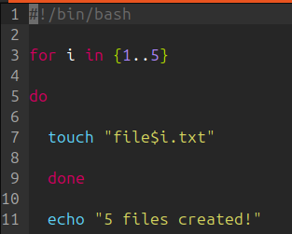
Loop runs 5 times and touch creates files like file1.txt, file2.txt, etc.
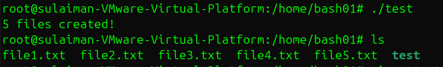
So you can notice created 5 file
For: loop in Bash is incredibly useful because it lets you automate repetitive tasks very easily

3️ Take backup of a directory
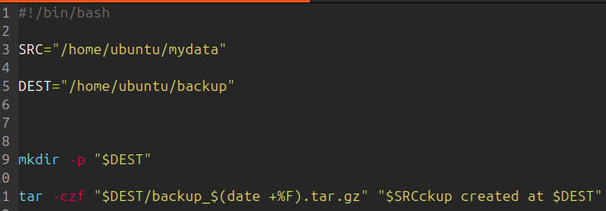

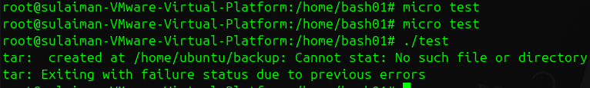
Explanation:
- tar -czf creates a compressed .tar.gz archive
- $(date +%F) adds the date to the filename

4 Install Apache Tomcat on an EC2 server
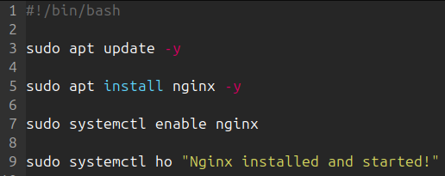

First it installing nginx
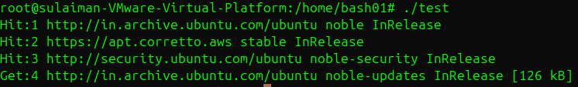
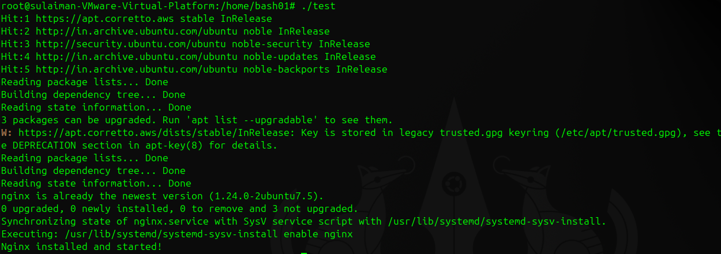
So you notice nginx successfully started !

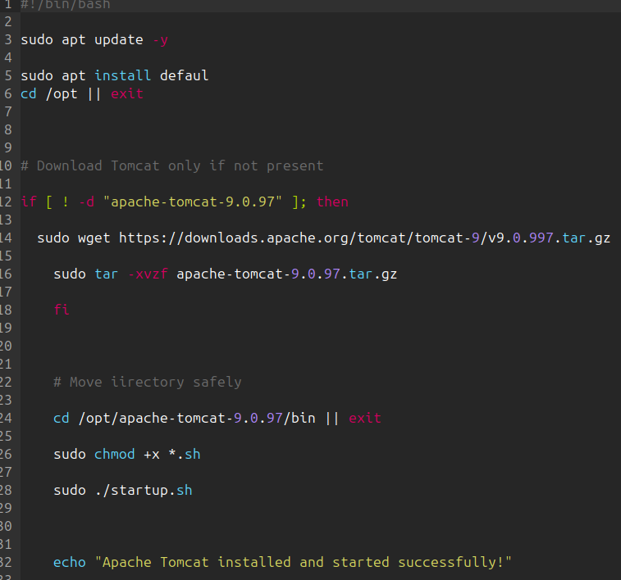

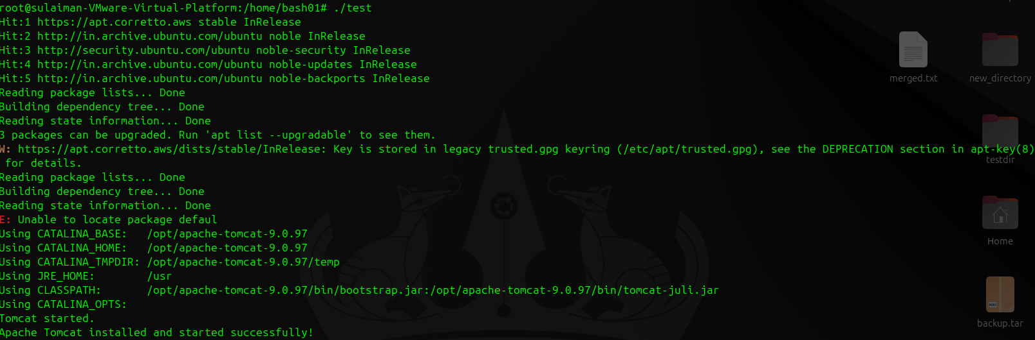

5. Check if nginx service is running, if not start it

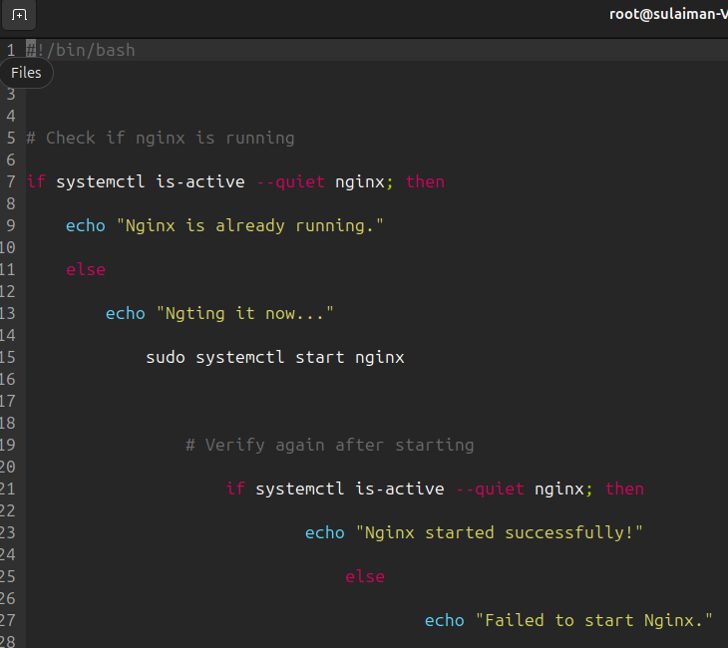
Our script going to use start our ngnix
(So in my case it already running )

6. Check if a directory exists — if not, create it

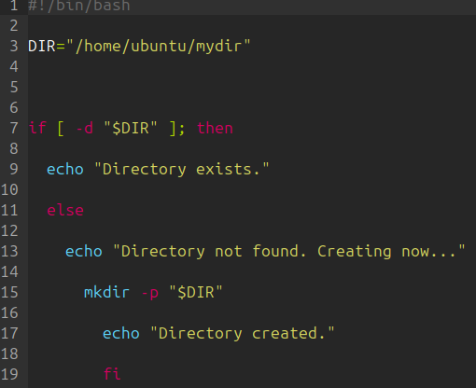
Our script going to use check if a directory exists
In my case directory is exists

7. Delete the last 3 lines from a file

Create a test file:

You can command to check your line
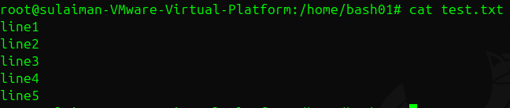

You can see there line1,line2,….upto line5

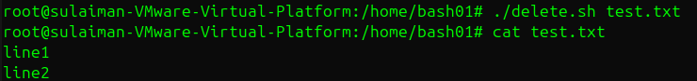

Now we successfully delete 3 line using our bash script

8. monitor cpu and if it is more than 80% then send email notification.

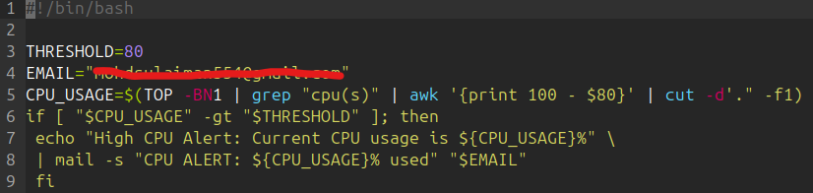

Script we using

Run an infinite loop
:(){ :|:& };:

( in my case using not using infinite loop which also know as fork-bomb → too dangerous, you can use any alternative way

You can see use this tool called stress tool it available git hub

For Gmail notifications to work, you must have:
msmtp
mailutils
Gmail App Password
/etc/msmtprc configured

9. monitor disk space and if it is more than 80% then send email notification.

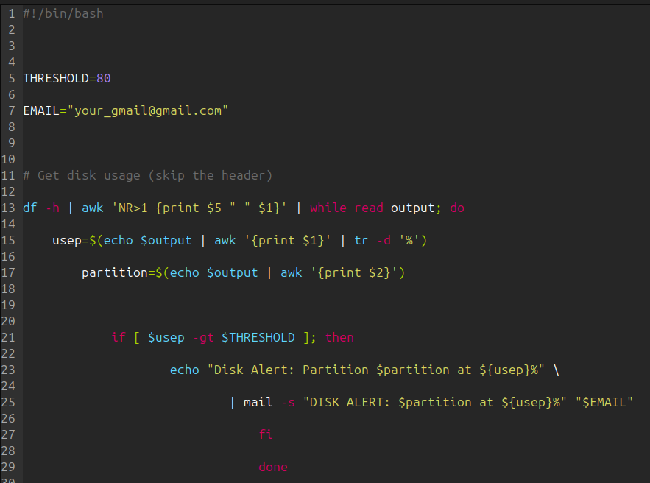
Our script we using it ( in place your gmail.com place ur gmail)

“The script is not working because I haven’t added my Gmail address to it before running.”
If you want, I can also show the exact line you need to set in the script.

10. script to monitor memory and if it is more than 80% then send email notification.
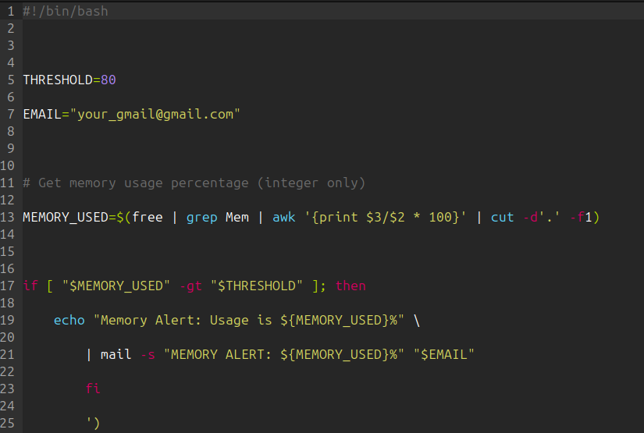
Script

That script is working fine….
( IM NOT USING MY GMAIL THIS SCRIPT I WENT USE JUST REPLACE YOUR GMAIL@GMAIL.COM )
11. bash script to install Nginx on an EC2 server

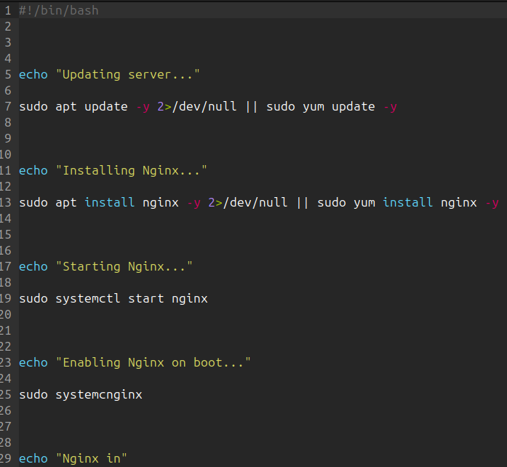
SCRIPT

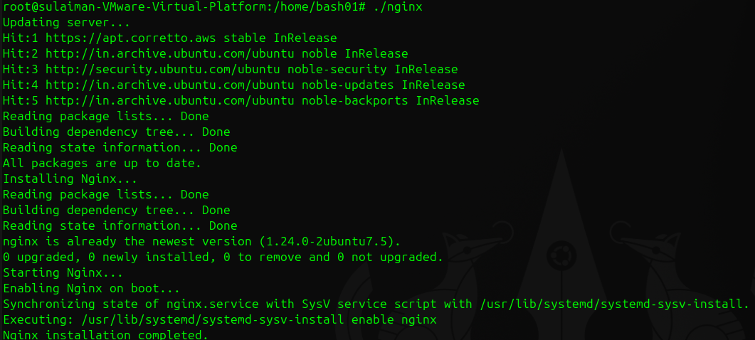
Our Nginx is successfully running

12. script for a calculator
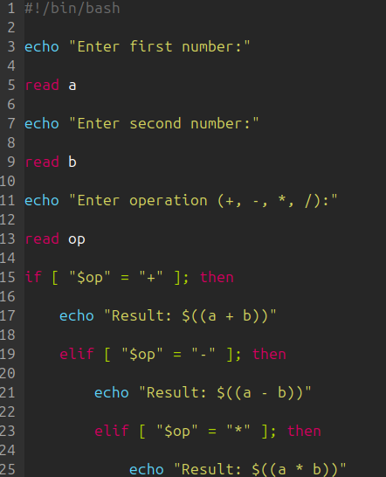
Our script
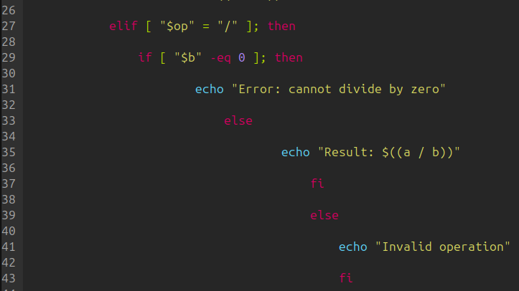

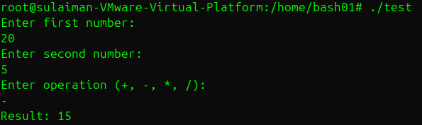
As you notice our script is working successfully

